Moving Car System Design

By : Team 4

# 

# 

# 

# 

# 

# 

# 

# **Table Of Content:**

1. Detailed Requirements
2. Layered architecture
3. System module
4. Module architecture
5. MCAL APIs  
   3.2.1 : DIO API  
    3.2.1.1 : Flowchart  
    3.2.1.2 : Type definitions  
    3.2.1.3 : Services  
   3.2.2 : Timer API  
    3.2.2.1 : Flowchart  
    3.2.2.2 : Type definitions  
    3.2.2.3 : Services  
   3.2.3 : Timer API  
    3.2.3.1 : Flowchart  
    3.2.3.2 : Type definitions  
    3.2.3.3 : Services  
   3.2.4 : External Interrupt API  
    3.2.4.1 : Flowchart  
    3.2.4.2 : Type definitions  
    3.2.4.3 : Services
6. HAL APIs  
   3.3.1 : LED API  
    3.3.1.1 : Flowchart  
    3.3.1.2 : Type definitions  
    3.3.1.3 : Services  
   3.3.2 : Motor API  
    3.3.2.1 : Flowchart  
    3.3.2.2 : Type definitions  
    3.3.2.3 : Services  
   3.3.3 : Car Control API  
    3.3.3.1 : Flowchart  
    3.3.3.2 : Type definitions  
    3.3.3.3 : Services  
   3.3.4 : Timer Manager API  
    3.3.4.1 : Flowchart  
    3.3.4.2 : Type definitions  
    3.3.4.3 : Services  
    3.3.5 : Interrupt Manager API  
    3.3.5.1 : Flowchart  
    3.3.5.2 : Type definitions  
    3.3.5.3 : Services  
    3.3.6 : Button API  
    3.3.6.1 : Flowchart  
    3.3.6.2 : Type definitions  
    3.3.6.3 : Services
7. APP APIs  
   3.4.1 : APP API  
    3.4.1.1 : Flowchart  
    3.4.1.2 : Type definitions  
    3.4.1.3 : Services

# 

# 

# 

# 

# 

# **1 : Detailed Requirements**

System Requirements:

1. The car starts initially from 0 speed

2. When PB1 is pressed, the car will move forward after 1 second

3. The car will move forward to create the longest side of the rectangle for 3 seconds with 50% of its maximum speed

4. After finishing the first longest side, the car will stop for 0.5 seconds, rotate 90 degrees to the right, and stop for 0.5 second

5. The car will move to create the short side of the rectangle at 30% of its speed for 2 seconds

6. After finishing the shortest side, the car will stop for 0.5 seconds, rotate 90 degrees to the right, and stop for 0.5 second

7. Steps 3 to 6 will be repeated infinitely until you press the stop button (PB2)

8. PB2 acts as a sudden break, and it has the highest priority

9. LEDs Operations

1. LED1: On means moving forward on the long side

2. LED2: On means moving forward on the short side

3. LED3: On means stop

4. LED4: On means Rotating

# 

# **2 : Layered architecture**

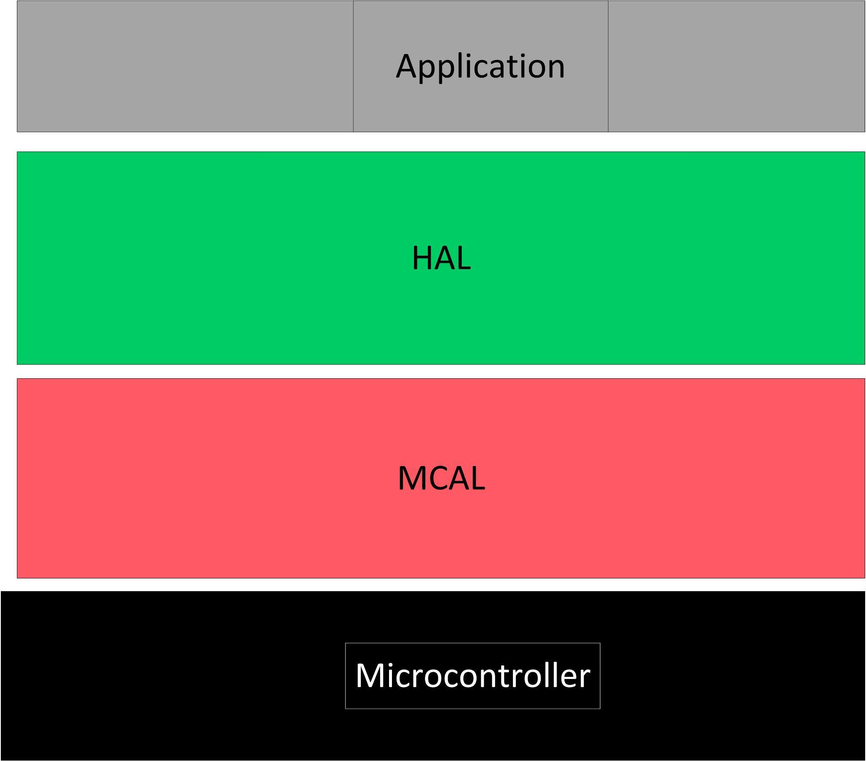

# **3 : System modules**

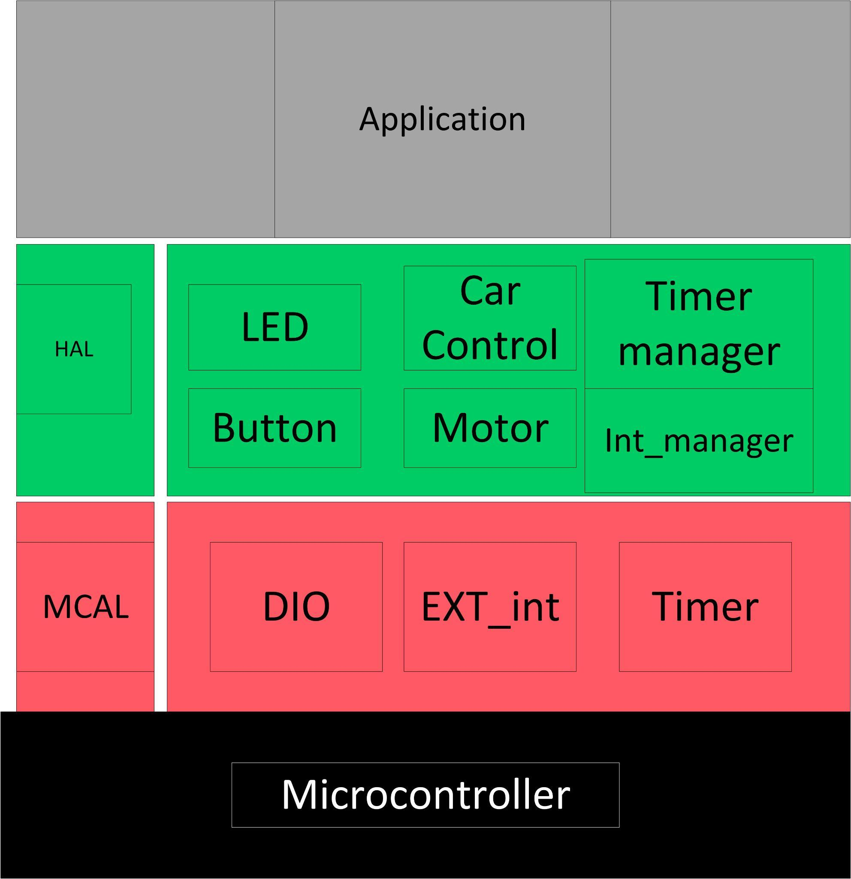

## **3.2 : MCAL APIs**

### 3.2.1 : DIO API :

#### 3.2.1.1 :Flowcharts:

#### 

#### 

#### 

#### 3.2.1.2 : Type definitions:

* en_dioPinsType

|  |  |
| --- | --- |
| Name | en_dioPinsType |
| Type | Enumeration |
| Range | Shall contain all pins ID |
| Description | en_dioPinsType |
| Available via | dio.h |

* en_dioPortsType

|  |  |
| --- | --- |
| Name | en_dioPortsType |
| Type | Enumeration |
| Range | Shall contain all ports ID |
| Description | en_dioPortsType |
| Available via | dio.h |

* u8_en_dioErrors

|  |  |
| --- | --- |
| Name | u8_en_dioErrors |
| Type | Enumeration |
| Range | |  |  |  | | --- | --- | --- | | DIO_E_OK | 0x00 | DIO error OK | | DIO_InvalidPin | 0x01 | DIO error, invalid pin number. | | DIO_InvalidPort | 0x02 | DIO error, invalid port number. | |
| Description | u8_en_dioErrors |
| Available via | dio.h |

* u8_en_dioLevelType

|  |  |
| --- | --- |
| Name | u8_en_dioLevelType |
| Type | Enumeration |
| Range | |  |  |  | | --- | --- | --- | | STD_LOW | 0x00 | Physical state 0V | | STD_HIGH | 0x01 | Physical state 5V or 3.3V. | |
| Description | u8_en_dioLevelType |
| Available via | dio.h |

* u8_en_dioDirType

|  |  |
| --- | --- |
| Name | u8_en_dioDirType |
| Type | Enumeration |
| Range | |  |  |  | | --- | --- | --- | | STD_INPUT | 0x00 | Set pin as input pin | | STD_OUTPUT | 0x01 | Set pin as output pin | |
| Description | u8_en_dioDirType |
| Available via | dio.h |

#### 

#### 3.2.1.3 : Services affecting the hardware unit:

* DIO_readPIN

|  |  |  |  |
| --- | --- | --- | --- |
| Service name | DIO_readPIN | | |
| Syntax | u8_en_dioErrors DIO_readPIN (  en_dioPortsType port,  en_dioPinsType pin,  uint8_t* value  ); | | |
| Parameters (in) | Port, pin | Channel ID | |
| value | Pointer to store the level | STD_HIGH |
| STD_LOW |
| Return | |  |  | | --- | --- | | u8_en_dioErrors | DIO_E_OK | | DIO_InvalidPin | | DIO_InvalidPort | | | |
| Description | This Function gets the level of the pin | | |

* This function shall return DIO_InvalidPin if pin number is invalid.
* This function shall return DIO_InvalidPort if port number is invalid.
* DIO_writePIN

|  |  |  |  |
| --- | --- | --- | --- |
| Service name | DIO_writePIN | | |
| Syntax | u8_en_dioErrors DIO_writePIN (  en_dioPortsType port, en_dioPinsType pin, u8_en_dioLevelType state  ); | | |
| Parameters (in) | Port, pin | Channel ID | |
| state | Value to be set | STD_HIGH |
| STD_LOW |
| Return | |  |  | | --- | --- | | u8_en_dioErrors | DIO_E_OK | | DIO_InvalidPin | | DIO_InvalidPort | | | |
| Description | This Function sets the level of the pin | | |

* This function shall return DIO_InvalidPin if pin number is invalid.
* This function shall return DIO_InvalidPort if port number is invalid.
* DIO_init

|  |  |  |  |
| --- | --- | --- | --- |
| Service name | DIO_init | | |
| Syntax | u8_en_dioErrors DIO_init (  en_dioPortsType port,  en_dioPinsType pin,  u8_en_dioDirType direction  ); | | |
| Parameters (in) | Port, pin | Channel ID | |
| direction | Value to be set | STD_INPUT |
| STD_OUTPUT |
| Return | |  |  | | --- | --- | | DIO_Errors | DIO_E_OK | | DIO_InvalidPin | | DIO_InvalidPort | | | |
| Description | This Function sets the Direction of the pin | | |

* This function shall return DIO_InvalidPin if pin number is invalid
* This function shall return DIO_InvalidPort if port number is invalid.

### 3.2.2 : Timer API :

#### 3.2.2.1 :Flowcharts:

#### 3.2.2.2 : Type definitions:

typedef enum{

E_NOT_OK = 0,

E_OK

}Std_ReturnType;

typedef enum

{

Timer0,Timer1,Timer2,INVALID_TIMER_TYPE

}TimerType_t;

typedef enum

{

NO_CLOCK,F_CPU_CLOCK,F_CPU_8,F_CPU_32,F_CPU_64,F_CPU_128,F_CPU_256,F_CPU_1024,

TIMER_EXTERNAL_CLK_FALLING_EDGE,TIMER_EXTERNAL_CLK_RISING_EDGE,

INVALID_TIMER_CLK

}TimerClock_t;

typedef enum

{

TIMER_NORMAL_MODE=0,

TIMER_PHASE_CORRECT_PWM_MODE,

TIMER_CTC_MODE,

TIMER_FAST_PWM_MODE,

INVALID_TIMER_MODE

}TimerMode_t;

typedef enum

{

CTC_Output_Compare_Mode_DISCONNECTED=0, /*Normal port operation, OCx disconnected.*/

CTC_Output_Compare_Mode_TOGGLE, /*Toggle OCx on compare match*/

CTC_Output_Compare_Mode_CLEAR, /*Clear OCx on compare match*/

CTC_Output_Compare_SET, /*Set OCx on compare match*/

CTC_INVALID_TIMER_OUTPUT_COMPARE_MODE

}Output_Compare_Mode_t;

typedef enum

{

FAST_Output_Compare_Mode_DISCONNECTED=0, /*Normal port operation, OCx disconnected.*/

FAST_Output_Compare_Mode_TOGGLE, /*Toggle OCx on compare match*/

FAST_Output_Compare_Mode_NON_INVERTED, /*Clear OCx on compare match, set OCx at BOTTOM*/

FAST_Output_Compare_Mode_INVERTED, /* Set OCx on compare match, clear OCx at BOTTOM*/

FAST_INVALID_TIMER_FAST_PWM_MODE

}FAST_PWM_MODE_t;

typedef enum

{

PC_Output_Compare_Mode_DISCONNECTED=0, /*Normal port operation, OCx disconnected.*/

PC_Output_Compare_Mode_TOGGLE, /*Toggle OCx on compare match*/

PC_Output_Compare_Mode_NON_INVERTED, /*Clear OCx on compare match when up-counting Set OCx on compare match when down counting*/

PC_Output_Compare_Mode_INVERTED, /*Set OCx on compare match when up-counting Clear OCx on compare match when down counting*/

PC_INVALID_TIMER_Phase_Correct_PWM_MODE

}Phase_Correct_PWM_Mode;

typedef struct

{

TimerType_t timer_type; /* @ref TimerType_t*/

TimerClock_t timer_clock; /* @ref TimerClock_t*/

TimerMode_t timer_mode; /* @ref TimerMode_t*/

Output_Compare_Mode_t output_compare_mode; /* @ref Output_Compare_Mode_t*/

FAST_PWM_MODE_t fast_pwm_mode; /* @ref FAST_PWM_MODE_t 8-bit resolution only*/

Phase_Correct_PWM_Mode phase_correct_pwm_mode; /* @ref Phase_Correct_PWM_Mode 8-bit resolution only*/

*uint16_t* timer_InitialValue; /* the pre-loaded value on Timer/Counter Register*/

*uint16_t* timer_compare_MatchValue; /* the top value on Output Compare Register*/

}Timer_Config_t;

#### 3.2.2.3 : Services affecting the hardware unit

/*

* Description: Function to Initialize Timer Driver

* - Working in Interrupt Mode

* - Choose Timer initial value

* - Choose Timer_ID (Timer0, Timer1, Timer2)

* - Choose Timer_Mode (OverFlow, Compare,PWM)

* - if using CTC mode choose Timer compare match value And choose q output_compare_mode

*

*@param A Reference of the Timer configuration

* @return status of the function

* E_OK :the function done successfully

* E_NOT_OK :the function has issues performing the function

*/

Std_ReturnType TIMERx_init(const Timer_Config_t *stPtr_a_Config);

/*

* Description : TIMER START COUNTING BY CONFIGURE THE TIMER CLOCK

* @param en_a_timer_clk :timer clock configuration with pres-scaler

en_a_timer_type :timer channel : timer0,timer1,timer2

* @return Std_ReturnType: status of the function

* E_OK :the function done successfully

* E_NOT_OK :the function has issues performing the function

*/

Std_ReturnType TIMERx_start(const TimerClock_t en_a_timer_clk,const TimerType_t en_a_timer_type);

/*

* Description : Call the Call Back function in the application after timer did its job

* @param A pointer to function & the timer type

* @return status of the function

* E_OK :the function done successfully

* E_NOT_OK :the function has issues performing the function

*/

Std_ReturnType TIMERx_setCallBack(void(*a_fptr)(void),const TimerType_t en_a_timer_type );

/*

* Description :set a certain value on the timer counting register

* @param the timer type and the initial value to be set

* @return status of the function

* E_OK :the function done successfully

* E_NOT_OK :the function has issues performing the function

*/

Std_ReturnType TIMERx_setValue(const TimerType_t en_a_timer_type ,const *uint16_t* u16_a_timer_value);

/*

* Description :this function sets the offset of the compare unit

* @param timer type and the top value to be compared with the TCNCx

* @return status of the function

* E_OK :the function done successfully

* E_NOT_OK :the function has issues performing the function

*/

Std_ReturnType TIMERx_CTC_SetCompare(const TimerType_t en_a_timer_type ,const *uint16_t* u16_a_compareValue);

/*

* Description :Function to make the timer to start again from beginning(reset)

* @param the timer type and the initial value to be set

* @return status of the function

* E_OK :the function done successfully

* E_NOT_OK :the function has issues performing the function

*/

Std_ReturnType TIMERx_reset(const TimerType_t en_a_timer_type);

/*

* Description :Function to Halt the timer (stop)

* @param the timer type and the initial value to be set

* @return status of the function

* E_OK :the function done successfully

* E_NOT_OK :the function has issues performing the function

*/

Std_ReturnType TIMERx_stop(const TimerType_t en_a_timer_type);

### 3.2.3 : External Interrupt API :

#### 3.2.3.1 : Flowcharts:

#### 3.2.3.2 : Type definitions:

/**datatype to hold the state of function and it has two options INT_E_OK || INT_E_NOK**/

typedef uint8_t u8_en_interruptErrorType;

#define INT_E_OK ((u8_en_interruptErrorType)0x00)// function done

#define INT_E_NOK ((u8_en_interruptErrorType)0x01)// function didn't do its behavior correctly

/* datatype of enum has three choices of interrupts

external interrupt 0, external interrupt 1, external interrupt 2

*/

typedef enum{

EXT_0=0,

EXT_1,

EXT_2

}ext_interrupt_no_t;

/* datatype of enum has four options of interrupt detection

low level, locical change, falling edge, rising edge

*/

typedef enum{

LOW_LEVEL,

LOGICAL_CHANGE,

FALLING_EDGE,

RISING_EDGE

}EDGE_detection_t;

#### 3.2.3.3 : Services affecting the hardware unit

/*

* -Description-

*-this function INIT the external interrupt configuration

*

* -Input Output parameters -

*-1-it is interrupt number (ext_interrupt_no_t ext_interrupt_no)

*-2-it is the interrupt condition (EDGE_detection_t EDGE_detection)

*

* -Return-

* u8_en_interruptErrorType

*

* -Return cases-

*-1- (INT_E_OK) if there is something wrong

*-2- (INT_E_NOK) otherwise

*/

u8_en_interruptErrorType ext_interrupt_init(ext_interrupt_no_t ext_interrupt_no, EDGE_detection_t EDGE_detection);

/*

* -Description-

*-this function enable external interrupt depend on external interrupt number

*

* -Input Output parameters -

*-1-it is interrupt number (ext_interrupt_no_t ext_interrupt_no)

*

*

* -Return-

* u8_en_interruptErrorType

*

* -Return cases-

*-1- (INT_E_OK) if there is something wrong

*-2- (INT_E_NOK) otherwise

*/

u8_en_interruptErrorType ext_interrupt_enable(ext_interrupt_no_t ext_interrupt_no);

/*

* -Description-

*-this function disable external interrupt depend on external interrupt number

*

* -Input Output parameters -

*-1-it is interrupt number (ext_interrupt_no_t ext_interrupt_no)

*

*

* -Return-

* u8_en_interruptErrorType

*

* -Return cases-

*-1- (INT_E_OK) if there is something wrong

*-2- (INT_E_NOK) otherwise

*/

u8_en_interruptErrorType ext_interrupt_disable(ext_interrupt_no_t ext_interrupt_no);

/*

* -Description-

*-this function set callback function to external interrupt

*

* -Input Output parameters -

*-1-it is pointer to call back function (void (*func)(void))

*

* -Return-

* u8_en_interruptErrorType

*

* -Return cases-

*-1- (INT_E_OK) if there is something wrong

*-2- (INT_E_NOK) otherwise

*/

u8_en_interruptErrorType ext_interrupt_set_callback_init(ext_interrupt_no_t ext_interrupt_no ,void(*callback)(void));

## **3.3 : HAL APIs**

### 3.3.1 : LED API:

#### 3.3.1.1 : Flowcharts:

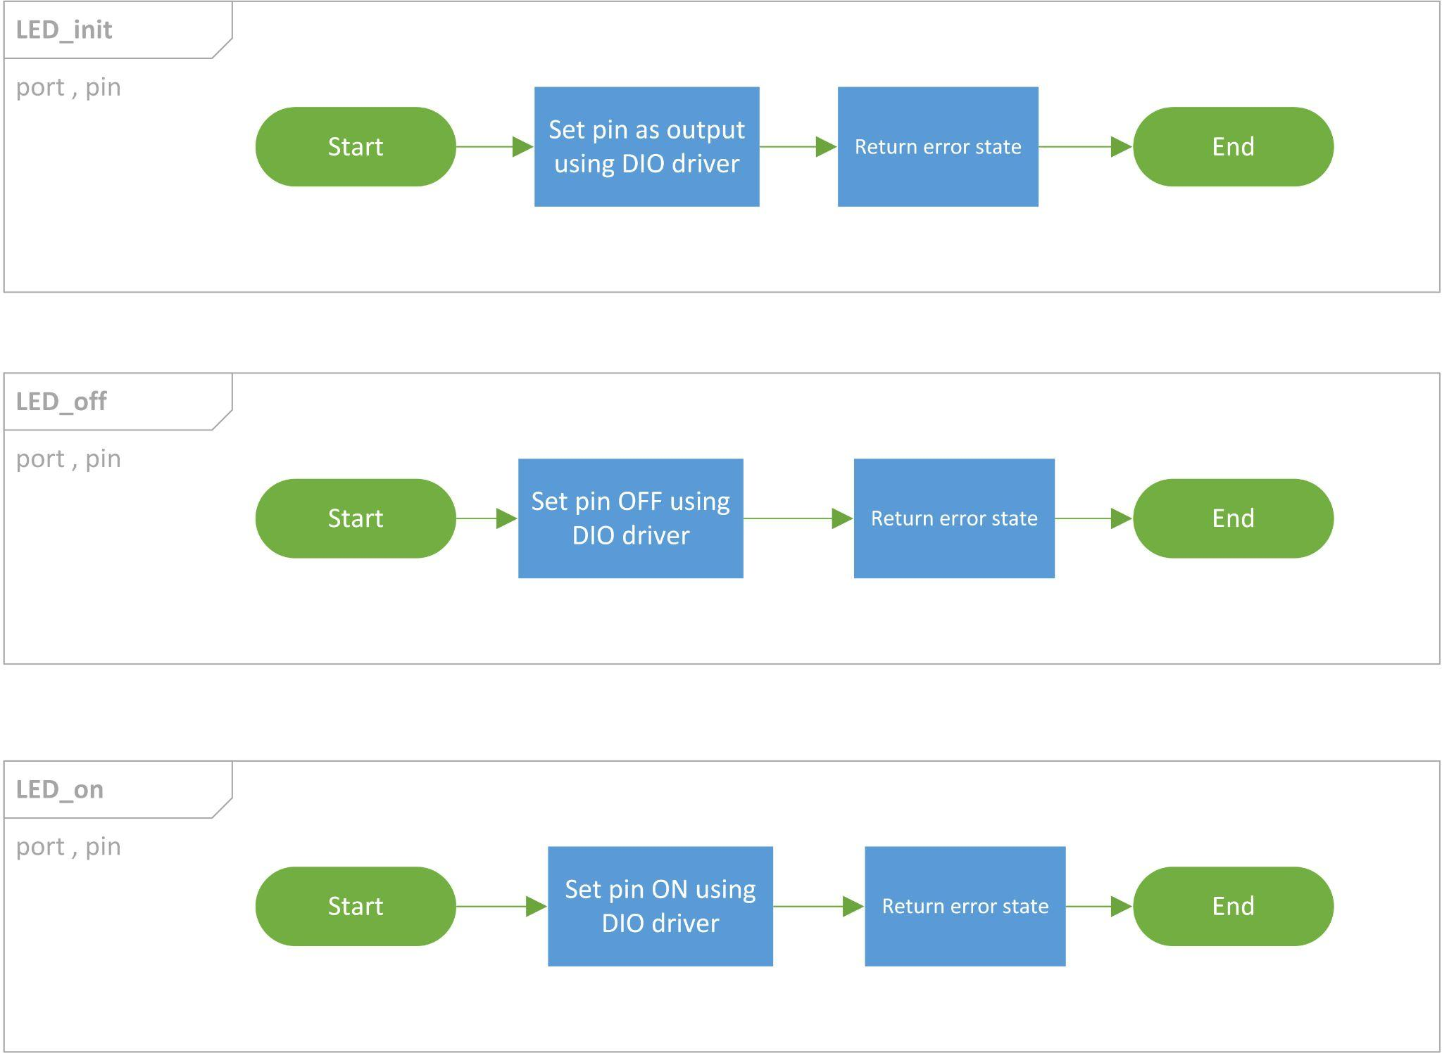

#### 3.3.1.2 : Type definitions:

* u8_en_ledStateType

|  |  |  |
| --- | --- | --- |
| Name | u8_en_ledStateType | |
| Type | Enumeration | |
| Range | LED_OFF | 0x00 |
| LED_ON | 0x01 |
| Description | u8_en_ledStateType | |
| Available via | led_types.h | |

* u8_en_ledErrorType

|  |  |  |
| --- | --- | --- |
| Name | u8_en_ledErrorType | |
| Type | Enumeration | |
| Range | LED_OK | 0x00 |
| LED_InvalidPin | 0x01 |
| LED_InvalidPort | 0x02 |
| Description | u8_en_ledErrorType | |
| Available via | led_types.h | |

* st_ledConfigType

|  |  |
| --- | --- |
| Name | st_ledConfigType |
| Type | structure |
| Description | st_ledConfigType |
| Available via | led_types.h |

#### 3.3.1.3 : Services affecting the hardware unit:

* LED_off

|  |  |  |
| --- | --- | --- |
| Service name | LED_off | |
| Syntax | u8_en_ledErrorType LED_off(  uint8_t u8_a_port,  uint8_t u8_a_pin  ); | |
| Parameters (in) | Port, pin | Channel ID |
| Return | |  |  | | --- | --- | | u8_en_ledErrorType | LED_OK | | LED_InvalidPin | | LED_InvalidPort | | |
| Description | This Function sets the level of the pin to low | |

* This function shall return DIO_InvalidPin if pin number is invalid.
* This function shall return DIO_InvalidPort if port number is invalid.
* LED_on

|  |  |  |
| --- | --- | --- |
| Service name | LED_on | |
| Syntax | u8_en_ledErrorType LED_on(  uint8_t u8_a_port,  uint8_t u8_a_pin  ); | |
| Parameters (in) | Port, pin | Channel ID |
| Return | |  |  | | --- | --- | | u8_en_ledErrorType | LED_OK | | LED_InvalidPin | | LED_InvalidPort | | |
| Description | This Function sets the level of the pin | |

* This function shall return DIO_InvalidPin if pin number is invalid.
* This function shall return DIO_InvalidPort if port number is invalid.
* LED_init

|  |  |  |
| --- | --- | --- |
| Service name | LED_init | |
| Syntax | u8_en_ledErrorType LED_init(  uint8_t u8_a_port,  uint8_t u8_a_pin  ); | |
| Parameters (in) | Port, pin | Channel ID |
| Return | |  |  | | --- | --- | | u8_en_ledErrorType | LED_OK | | LED_InvalidPin | | LED_InvalidPort | | |
| Description | This Function sets the Direction of the led pin as output | |

* This function shall return LED_InvalidPin if pin number is invalid
* This function shall return LED_InvalidPort if port number is invalid.

### 3.3.2 : Motor API:

#### 3.3.2.1 : Flowcharts:

#### 3.3.2.2 : Type definitions:

typedef struct ST_motor_t

{

en_dioPortsType port;

en_dioPinsType pin_num1;

en_dioPinsType pin_num2;

}ST_motor_t;

typedef enum EN_motor_error_t

{

MOTOR_OK,

MOTOR_NOK

}EN_motor_error_t;

#### 3.3.2.3 : Services affecting the hardware unit:

/************************************************************************

* description: this function used to init the motor as output

* input : pointer to structure which have port and two pin number

* return :MOTOR_OK or MOTR_NOK

************************************************************************/

EN_motor_error_t MOTOR_INIT(const ST_motor_t* motor);

/************************************************************************

* description : this function used to move the motor forward

* input : pointer to structure which have port and two pin number and speed of motor

* return :MOTOR_OK or MOTR_NOK

************************************************************************/

EN_motor_error_t MOTOR_FORWARD(const ST_motor_t* motor);

/************************************************************************

* description : this function used to move the motor backward

* input : pointer to structure which have port and two pin number and speed of motor

* return :MOTOR_OK or MOTR_NOK

************************************************************************/

EN_motor_error_t MOTOR_BACKWARD(const ST_motor_t* motor);

/************************************************************************

* description : this function used to stop the motor

* input : pointer to structure which have port and two pin number

* return :MOTOR_OK or MOTR_NOK

************************************************************************/

EN_motor_error_t MOTOR_STOP(const ST_motor_t* motor);

### 3.3.3 : Car Control API :

#### 3.3.3.1 : Flowcharts:

#### 3.3.3.2 : Type definitions:

typedef enum EN_car_error_t

{

CAR_OK,

CAR_NOK,

}EN_car_error_t;

#### 3.3.3.3 : Services affecting the hardware unit

/************************************************************************

*description : used to initlize the two motor as output

*input : this function take two pointers to motor structure

*return : MOTOR_OK, MOTOR_NOK

************************************************************************/

EN_car_error_t CAR_INIT(const ST_motor_t* motor_1,const ST_motor_t* motor_2);

/************************************************************************

*description : used to move the car forward by specific speed

*input : this function take two pointers to motor structure and speed of the car

*return : MOTOR_OK, MOTOR_NOK

************************************************************************/

EN_car_error_t CAR_FORWARD(const ST_motor_t* motor_1,const ST_motor_t* motor_2);

/************************************************************************

*description: used to reverse the car to the right

*input : this function take two pointers to motor structure and speed of the car

*return : MOTOR_OK, MOTOR_NOK

************************************************************************/

EN_car_error_t CAR_REVERSE_RIGHT(const ST_motor_t* motor_1,const ST_motor_t* motor_2);

/************************************************************************

*description : used to stop the car

*input : this function take two pointers to motor structure

*return : MOTOR_OK, MOTOR_NOK

************************************************************************/

EN_car_error_t CAR_STOP(const ST_motor_t* motor_1,const ST_motor_t* motor_2);

### 3.3.4 : Timer Manager API :

#### 3.3.4.1 : Flowcharts:

#### 3.3.4.2 : Type definitions:

typedef void (*Fptr) (void);

typedef struct

{

TimerType_t timer_num; /* @ref TimerType_t*/

TimerMode_t timer_mode; /* @ref TimerMode_t*/

*uint16_t* timer_InitialValue; /* the pres-loaded value on Timer/Counter Register*/

*uint16_t* timer_compare_MatchValue; /* the top value on Output Compare Register*/

Fptr call_back_function; /*pointer to function that take void and return nothing(void) ,should loaded with call-back function's address*/

}TimerManger_config_t;

#### 3.3.4.3 : Services affecting the hardware unit

/*

* Description: Function to Initialize Timer Driver

* - Working in Interrupt Mode

* - set Timer initial value

* - set Timer_ID (Timer0, Timer1, Timer2)

* - set Timer_Mode(OverFlow, Compare,PWM)

* - if using CTC mode choose Timer compare match value And choose output_compare_mode

*

*@param stPtr_a_TimerConfig :A Reference of the Timer configuration

* @return Std_ReturnType : status of the function

* E_OK :the function done successfully

* E_NOT_OK :the function has issues performing the function

*/

Std_ReturnType TIMER_MANGER_init(const TimerManger_config_t *stPtr_a_TimerConfig);

/*

* Description : TIMER START COUNTING BY CONFIGURE THE TIMER CLOCK

* @param en_a_timer_clk :timer clock configuration with pres-scaler

en_a_timer_num :timer channel : timer0,timer1,timer2

* @return Std_ReturnType: status of the function

* E_OK :the function done successfully

* E_NOT_OK :the function has issues performing the function

*/

Std_ReturnType TIMER_MANGER_start(const TimerClock_t en_a_timer_clock,const TimerType_t en_a_timer_num);

/*

* Description :Function to Halt the timer (stop)

* @param the en_a_timer_num timer type

* @return status of the function

* E_OK :the function done successfully

* E_NOT_OK :the function has issues performing the function

*/

Std_ReturnType TIMER_MANGER_stop(const TimerType_t en_a_timer_num);

### 3.3.5 : Interrupt Manager API :

#### 3.3.5.1 : Flowcharts:

#### 3.3.5.1 : Type definitions:

/*

*

*

* -ext_interrupt_config_t datatype hold the external interrupt config

* -Members-

* -1- (ext_interrupt_no_t ext_interrupt_no) number of external interrupt

* -2- (EDGE_detection_t edge_select) the state of line will fire the interrupt

*

*/

typedef struct

{

ext_interrupt_no_t ext_interrupt_no;

EDGE_detection_t edge_select;

}ext_interrupt_config_t;

#### 3.3.5.1 : Services affecting the hardware unit

/*

* -Description-

*-this function init the external interrupt configuration

*

* -Input Output parameters -

*-1-it is configuration of external interrupt (ext_interrupt_config_t *ext_interrupt_config)

*-2-it is pointer to callback function (void(*callback)(void))

*

* -Return-

* u8_en_interruptErrorType

*

* -Return cases-

*-1- (INT_E_OK) if there is something wrong

*-2- (INT_E_NOK) otherwise

*/

u8_en_interruptErrorType ext_init(ext_interrupt_config_t *ext_interrupt_config, void(*callback)(void));

/*

* -Description-

*-this function enable external interrupt depend on external interrupt configuration

*

* -Input Output parameters -

*-1-it is configuration of external interrupt (ext_interrupt_config_t *ext_interrupt_config)

*

*

* -Return-

* u8_en_interruptErrorType

*

* -Return cases-

*-1- (INT_E_OK) if there is something wrong

*-2- (INT_E_NOK) otherwise

*/

u8_en_interruptErrorType ext_enable(uint8_t u8_intNum);

/*

* -Description-

*-this function disable external interrupt depend on external interrupt configuration

*

* -Input Output parameters -

*-1-it is configuration of external interrupt (ext_interrupt_config_t *ext_interrupt_config)

*

*

* -Return-

* u8_en_interruptErrorType

*

* -Return cases-

*-1- (INT_E_OK) if there is something wrong

*-2- (INT_E_NOK) otherwise

*/

u8_en_interruptErrorType ext_disable(uint8_t u8_intNum);

### 3.3.6: Button API:

#### 3.3.6.1: Flowcharts:

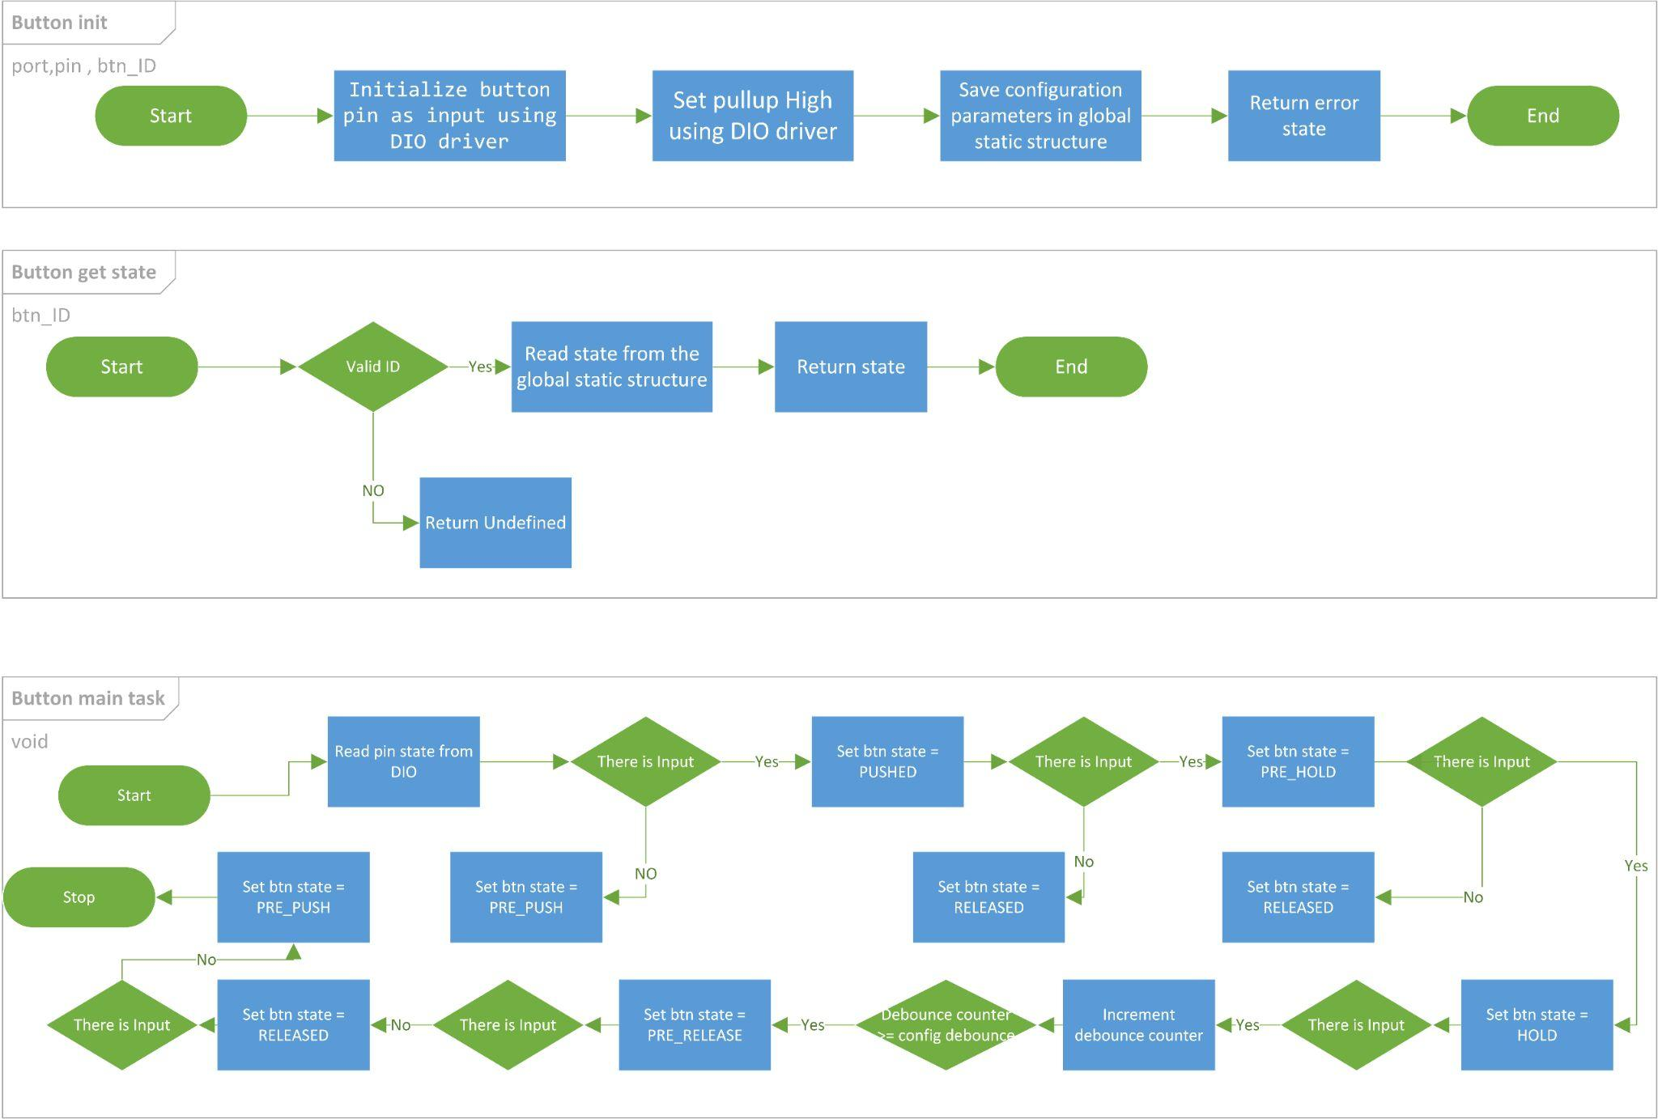

#### 3.3.6.2 : Type definitions:

* st_btnConfigType

|  |  |
| --- | --- |
| Name | st_btnConfigType |
| Type | Structure |
| Description | This is the type of the external data structure containing the overall configuration data for the Button API |
| Available via | button_types.h |

* u8_en_btnLevelType

|  |  |
| --- | --- |
| Name | u8_en_btnLevelType |
| Type | Enumeration |
| Range | |  |  |  | | --- | --- | --- | | BT_PUSH_LEVEL | 0x00 | Push Level | | BT_RELEASE_LEVEL | 0x01 | Release Level | |
| Description | Button Level Enum |
| Available via | button_types.h |

* u8_en_btnStateType

|  |  |
| --- | --- |
| Name | u8_en_btnStateType |
| Type | Enumeration |
| Range | |  |  |  | | --- | --- | --- | | BT_PRE_PUSH | 0x00 | Pre Push Level | | BT_PUSHED | 0x01 | Pushed Level | | BT_PRE_HOLD | 0x02 | Pre Hold Level | | BT_HOLD | 0x03 | Hold Level | | BT_PRE_RELEASE | 0x04 | Pre Release Level | | BT_RELEASED | 0x05 | Released Level | | BT_UNDEFINED | 0x06 | Undefined | |
| Description | Button state Enum |
| Available via | button_types.h |

* Button_IdType

|  |  |
| --- | --- |
| Name | u8_en_btnIdType |
| Type | Enumeration |
| Range | |  |  |  | | --- | --- | --- | | Button_Start | 0x00 | Start Button | |
| Description | Button ID Enum |
| Available via | button_types.h |

#### 3.3.6.2 : Services affecting the hardware unit

* BUTTON_getState

|  |  |  |
| --- | --- | --- |
| Service name | BUTTON_getState | |
| Syntax | u8_en_btnStateType BUTTON_getState(  u8_en_btnIdType en_btnId  ); | |
| Parameters (in) | en_btnId | Start 0x00 |
| Return | |  |  | | --- | --- | | Button_StateTyp | BT_PRE_PUSH | | BT_PUSHED | | BT_PRE_HOLD | | BT_HOLD | | BT_PRE_RELEASE | | BT_RELEASED | | BT_UNDEFINED | | |
| Description | This Function gets the Button state. | |

## 

* button_Main_Task

|  |  |
| --- | --- |
| Service name | button_Main_Task |
| Syntax | void button_Main_Taskt(  void  ); |
| Parameters (in) | NONE |
| Return | NONE |
| Description | This Function update all button states  Shall call periodic |

* BUTTON_init

|  |  |  |
| --- | --- | --- |
| Service name | BUTTON_init | |
| Syntax | u8_en_btnStateType BUTTON_init(  uint8_t u8_a_port,  uint8_t u8_a_pin,  u8_en_btnIdType en_btnId  ); | |
| Parameters (in) | Port, pin | Channel ID |
| en_btnId | Start 0x00 |
| Return | |  |  | | --- | --- | | Button_StateTyp | BT_PRE_PUSH | | BT_UNDEFINED | | |
| Description | This Function sets the Direction of the button pin as input | |

## **3.4 : App APIs**

### 3.4.1: App API:

#### 3.4.1.1: Flowcharts:

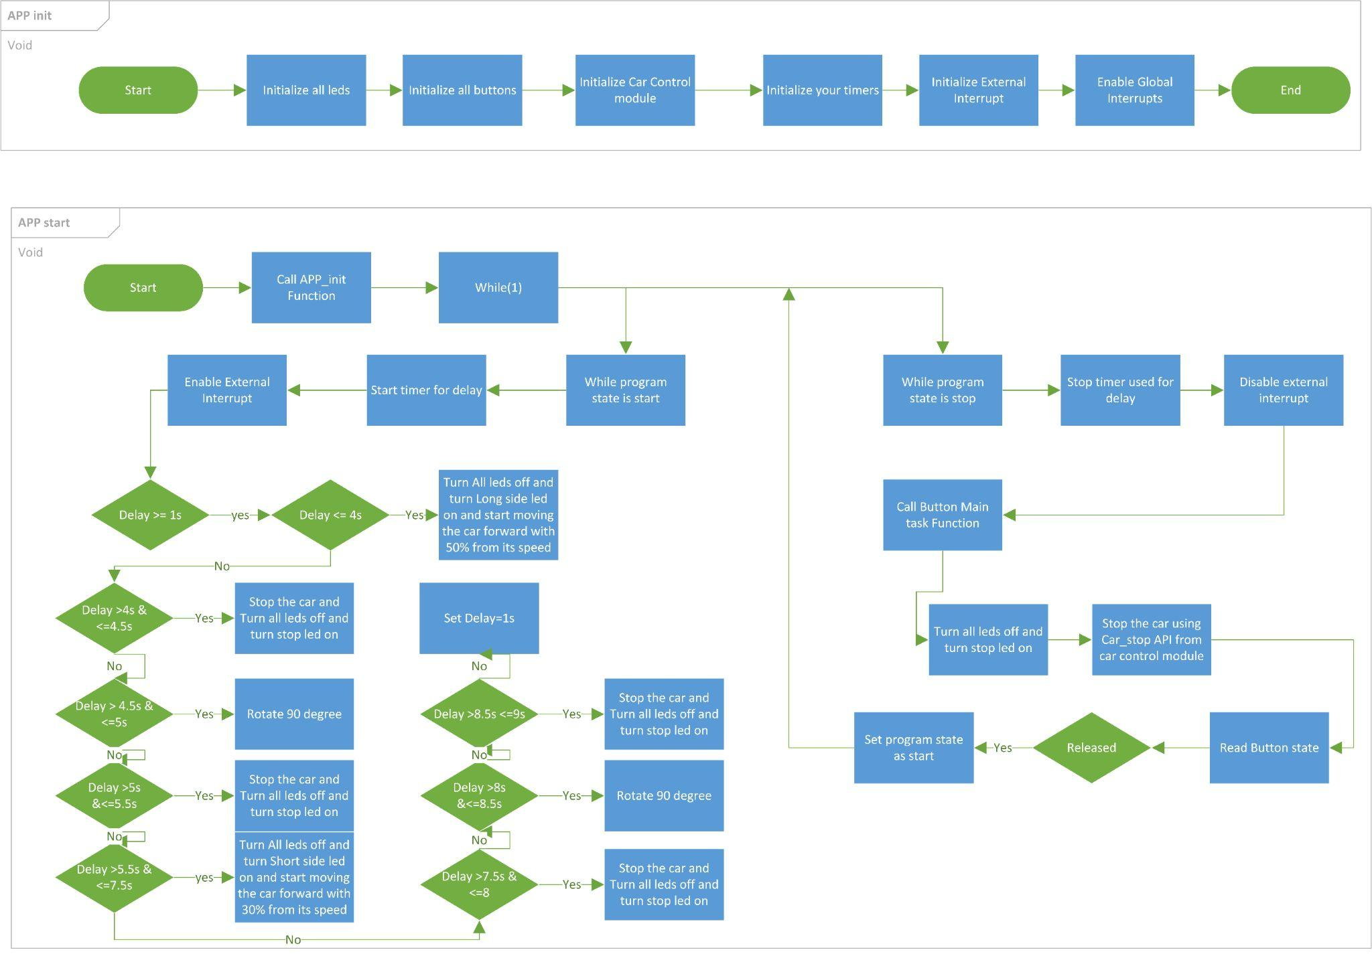

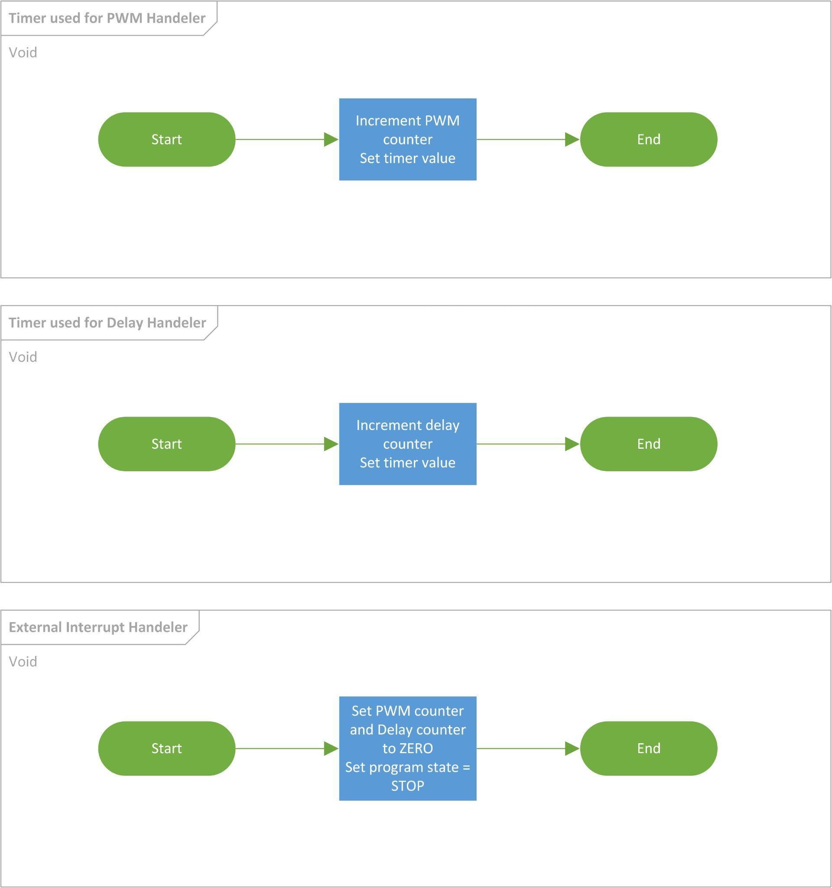

#### 3.4.1.2 : Type definitions:

* u8_en_PROGRAM_STATE

|  |  |
| --- | --- |
| Name | u8_en_PROGRAM_STATE |
| Type | Enumeration |
| Range | |  |  |  | | --- | --- | --- | | BTN_START | 0x00 | Program start | | BTN_STOP | 0x01 | Program stop | |
| Description | u8_en_PROGRAM_STATE |
| Available via | app.h |

* u8_en_ledIdType

|  |  |
| --- | --- |
| Name | u8_en_ledIdType |
| Type | Enumeration |
| Range | |  |  |  | | --- | --- | --- | | LED_SHORT_SIDE | 0x00 | Short Side LED | | LED_LONG_SIDE | 0x01 | Long Side LED | | LED_STOP | 0x02 | Stop LED | | LED_ROTATE | 0x03 | Rotate LED | |
| Description | u8_en_ledIdType |
| Available via | app.h |

#### 3.4.1.3 : Services affecting the hardware unit

* APP_start

|  |  |
| --- | --- |
| Service name | APP_start |
| Syntax | void APP_start(void); |
| Description | This Function Start the Application. |
| Available via | app.h |

* APP_init

|  |  |
| --- | --- |
| Service name | APP_init |
| Syntax | void APP_init(void); |
| Description | This function initialize all drivers used in the application. |
| Available via | app.c |

## 